Discussion Starter
Practical Think Tank – GPEI Issue 1: Cross-border vaccination & communication
Quick Overview
Principles:
- Country PEI programmes lead and make final decisions on strategy and action.
- Outside perspectives can help inform country decision-making processes – as one part of the knowledge and ideas gathering process.

Focus issue:
- Strategic plans identify the main country priorities.
- Within strategic plans there are particular, specific issues that could benefit from in-depth attention.
- Outside perspectives and input can be a valuable part of that in-depth analysis and ideas generation.
- One such issue identified by both Afghanistan and Pakistan is cross-border transmission and spread.
- Cross-border strategies are central in the NEAPs (National Emergency Action Plan) of both countries and have been identified by oversight bodies as areas for priority action.
- Effective communication strategies are vital to address and interrupt cross-border spread.
- Within both the polio programmes of Pakistan and Afghanistan as well as other regions (eg Horn of Africa and the Chad basin) and across other development issues (eg HIV/AIDS, migration, conflict, child and maternal health) there is considerable experience with cross-border action.
Cross-border transmission and spread – a communication perspective
Key elements include (see fuller paper in the pages that follow):
- Pakistan and Afghanistan are one epidemiological block.
- Genetic sequencing and environmental sample data clearly show that the polio virus is carried back and forth (see Figure 8).
- Population movement takes place for family, festival, seasonal, trade, employment and labour purposes and is also impacted by high levels of insecurity particularly in Afghanistan.
- Mobile populations are constituted by a range of a different groups e.g. nomads, migrants, IDPs, agricultural laborers, visitors to shrines and religious places especially during festivals.
- Many are underserved, under-reached and/or inaccessible and underutilizing public services.
- There are 3 main routes – the Northern, Central and Southern corridors.
- Together these pose significant operational and communication challenges.
The Pakistan and Afghanistan cross-border strategies
A focus on mapping high risk mobile populations (HRMP) – routes, points of origin/destination; periodic tele/ videoconferencing; synchronisation of SIAs; localised engagement between regions and teams at border crossings; vaccination teams at strategic transit points; and maximising immunisation at border crossings.

Assumptions:
The present communication strategy appears to be based on these assumptions
- Vaccinating children enroute at borders and strategic transit points is easier than vaccinating them at points of origin and/or destination – but is it as effective?
- The main strategies are the right ones but need to be implemented more effectively – are there gaps or other approaches that could be used?
- The past few years have seen major changes in the security situations of people in both countries especially in South KP and southern Afghanistan – has the programme adapted to these changes and is it preparing scenarios for worsening or improving contexts going forward?
- The Pashtun form the majority population living along the border and for many kilometres inland on both sides they also form much of the mobile population and are most effected by security issues – to what extent have communication efforts been focused on engaging this complex ethnic group and understanding its local contexts?
Questions for expert group to consider:
- What is your critical assessment of the programme strategy and its communication activities – does the approach and activities fit the problem?
- What are three practical communication action steps you would suggest that the polio programmes in Pakistan and Afghanistan consider to further strengthen their work focused on closing down cross-border viral movement?
Practical Think Tank – GPEI Issue 1: Cross-border vaccination & communication
Overall focus
When Development issues straddle national borders the absence of a cohesive approach on both sides of the line can and will undermine effective action and positive results. This has applied and continues to apply to issues as diverse (but connected) as HIV/AIDS, climate change, maternal mortality, education, child rights, poverty, migration (of course) and many more. Polio has faced this issue in many high priority contexts including the Chad Basin (northern Nigeria, Chad, Niger, CAR), the Horn of Africa, and of course in the two remaining endemic countries Pakistan and Afghanistan.
The cross-border challenge is of particular importance for communication. The full breadth and depth of human communication, from digital connections and knowledge sharing to in-person discussion and contact, easily cross national borders. This especially applies to people living in neighbouring border communities and those with the same or similar cultural base.
From your experience we are interested in the practical learning that you have accrued about how best to work in cross-border contexts.
There are two types of practical learning that could be the focus for your contribution, consequent discussion and distillation into a few specific, practical ideas for the consideration by the polio programmes in Afghanistan and Pakistan:
- Any particular learning from specific cross-border initiatives in which you have been involved that are relevant to the cross boarder communication issues faced by Pakistan and Afghanistan.
- Specific ideas related to effective communication interventions in cross-border situations that could be easily implemented or integrated with existing activities to improve the programme’s ability to consistently vaccinate more children. Your contribution could for example present ideas for engaging marginalised and underserved communities; how to use digital based networks in security compromised or hard to reach areas; partnering with communities on both sides: approaches for cross border negotiation, engagement and information sharing; identifying silent/hidden communication dynamics between people and communities; how to sustain local media relationships with cross border reach and many others.
Of course local realities are the foundation upon which effective communication is built and the border between Pakistan and Afghanistan is unique in its history as are the people and communities that live along it. What follows is a brief note that provides some context on the border and the people who cross it regularly together with an outline of the major strategies and approaches that have been central to polio’s cross border work over the past several years and their impact. At the end are a set of questions we hope will help focus discussion and the formulation of the practical ideas the group will develop for the countries.
Context
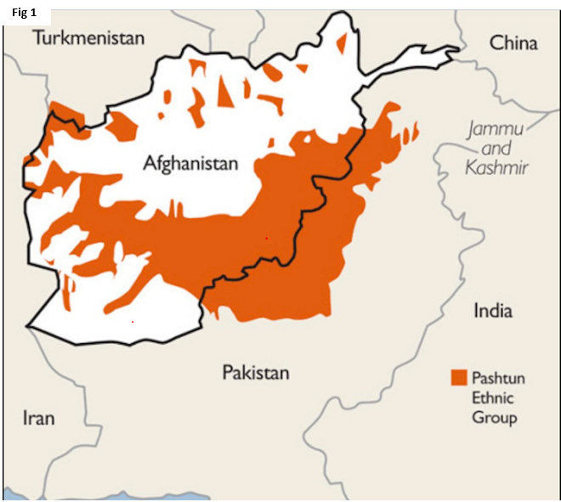
As with many countries the border between Pakistan and Afghanistan has a history that does not reflect or delineate a separation between distinct ethnic or cultural groups. The Durand line which forms the international border between Pakistan and Afghanistan, has its origins in the outcome of Anglo/Afghan wars. As Figure 1 shows it runs right through the middle of areas dominated by Pashtun speaking peoples and there are deep tribal, cultural, family and economic ties that lead to high levels of population movement across the border.

Genetic sequencing data on Polio cases and environmental samples clearly indicate that population on the move carry the polio virus back and forth from one area to the other and also across the border on a continuous basis. The burden of polio cases over time shows the substantial susceptibility of Pashto-speaking populations (see Figure 2 for data in Pakistan).

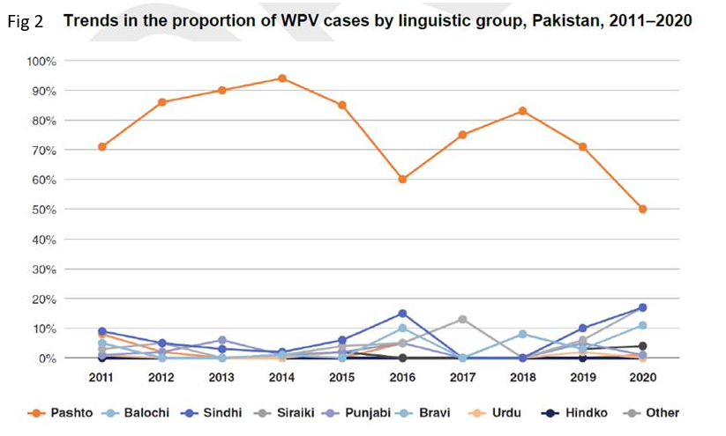
Population movement via formal and informal crossing points between Afghanistan and Pakistan – for family, festival, seasonal, trade, employment and labour purposes – unites the two countries in a single epidemiological bloc. The programme has defined three main corridors for this movement and transmission:
- The Southern Corridor: The Southern Region (SR) of Afghanistan bordering the Pakistan province of Baluchistan, constitute an axis of transmission which extends up to Helmand and Northern Sindh.
- The Northern Corridor: The second shared corridor of transmission includes northern and central Khyber Pakhtunkhwa (KP) province and Afghanistan’s Eastern Region (ER).
- The Central Corridor: The third is between South KP and Southeastern Region (SER) of Afghanistan.
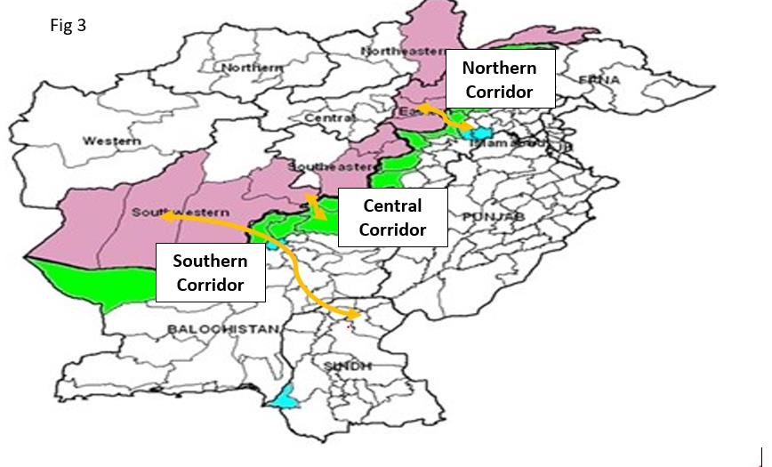

So cross-border transmission is a major issue that is concentrated along three main routes and within an ethnic group straddling the border that shares many ties and moves between localities that present very different contexts.

Mobile and migrant populations play a major role in sustaining virus transmission due to:
- Their highly mobile nature (e.g. nomads, migrants, IDPs, agricultural laborers, visitors to shrines and religious places especially during festivals) and primarily the continuous back and forth movement of families between different known poliovirus reservoirs areas.
- Being primarily “Underserved”, under-reached and/or inaccessible and perhaps also underutilizing public services.

Key Elements of PEI Cross-border Strategy
Strengthening cross border coordination and communication has been a long-standing request from IMB, TAG, IHR Emergency Committee and a strategic priority in both country’s annual polio National Emergency Action Plans (NEAPs).
A significant amount of energy and programme time/resource has been put into increasingly sophisticated forms of high risk mobile population (HRMP) mapping – points of origin, routes, points of destination – and HRMP types/sub-types (see Figures 4 and 5 from 2018).
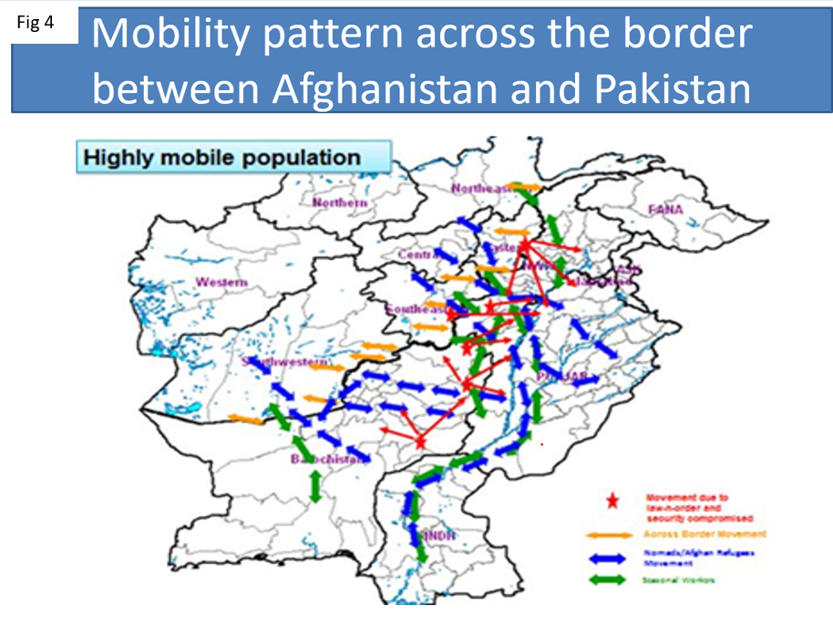
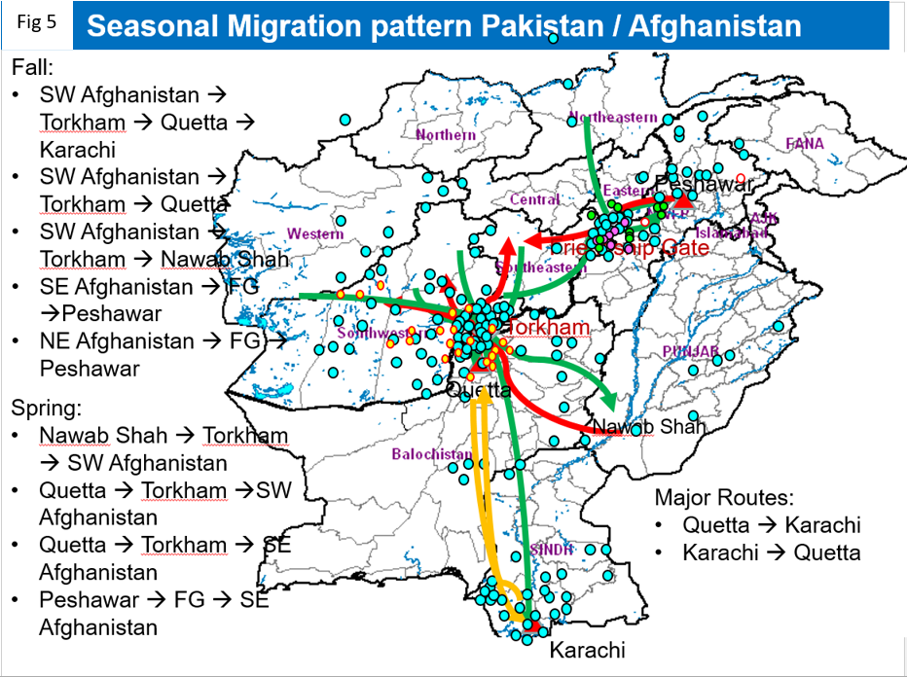

Keeping this type of analysis up to date and rigorous, especially in the context of insecurity and conflict in Afghanistan leading to unpredictable disruptions in migratory patterns and population movement, has proven difficult for the PEI and requires ongoing and significant investment.
The question could be asked what levels and types of analytical disaggregation are needed to generate additional value for strategic response.

Core PEI strategy on the cross-border problem has for some time focused on:
- Enhancing cross-border coordination – mainly through periodic tele/ videoconferencing between the two national EOCs; attempted synchronisation of SIAs; localised engagement between regional EOCs and country teams at/around border crossing points and through mapping of border areas
- Mapping movement within both countries and between them, disaggregating by population type/reason for movement, seasonality
- Deploying vaccination teams (fixed post and roving) to major formal crossing points (such as Torkham along the northern corridor, and Friendship Gate along the southern corridor but also other smaller official border crossings)
- Attempting to immunise all children crossing the border, including advocating raising the age threshold to 10 years – mainly assessed as absolute numbers of vaccinated children in the absence of clear targets or baseline
- Deploying roving, temporary or permanent vaccination teams at known transit points within both countries

A cross border concept note prepared in 2020 identified the following areas to focus on:
- Immunising all children crossing at major and minor official border posts
- Segmenting and mapping the movements of different populations - nomads, displaced people, migrant agricultural workers, those traveling to shrines and religious celebrations/festivals

This concept note identified the following as areas that needed to be incorporated in the programme and/or further developed:
- Developing and sustaining a strong coordination framework at national and subnational level that defines the areas of coordination, focal persons, frequency and modality.
- Synchronization of SIA calendars so that major immunisation campaigns happen at the same time on both sides of the border.
- Ensuring that permanent cross border vaccination posts are properly placed and operated to maximise coverage.
- Having up to date action plans for all the three corridors.
- Mapping and tracking of high-risk mobile populations (HRMP) crossing the border on either side with special reference to knowing their patterns of movement and where they settle after crossing.
- Continuously identifying and mapping issues along border areas including
  - Regularly updated micro-plans in the bordering areas
  - Mapping of bordering villages and settlements including refugees

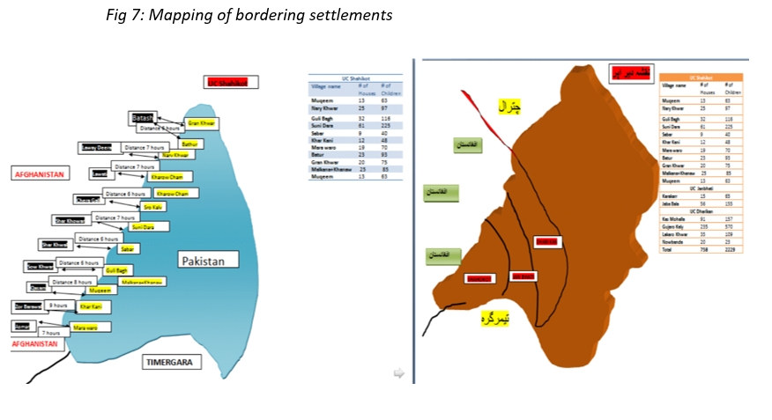
  - Identifying areas of concern with suboptimal coverage or reach around the borders and developing plans to address
  - Identifying community assets that can be used for promotion of vaccination and mapping of influencers
  - Sharing information related to vaccine acceptance, community engagement plans and developing mechanisms to enable free flow of information exchange between the two countries.

All of these proposed activities can be found in past and current strategy. And yet cross border transmission continues. The implication is that they are not being conducted adequately, and that the main line of future strategy should be to reinforce and improve existing practice. Given longstanding evidence that current practice has been unable to fully interrupt cross-border carriage of virus, it may be that current strategy is missing key areas of action. What kinds of communication interventions could help strengthen existing practises and/or fill gaps in present strategy?

Impact
The programme has focused significant resources on trying to capture eligible children during transit at borders and transit points. It is not clear that this is having the desired effect. Virus continues to move back and forth across the border occasionally re-seeding transmission in areas formerly cleared, and perpetuating reservoir transmission. Focusing on transit may miss opportunities at point of origin/point of destination to maximise vaccination coverage but requires not only the identification of those points but also strategies to build trust and engage with people in those populations.
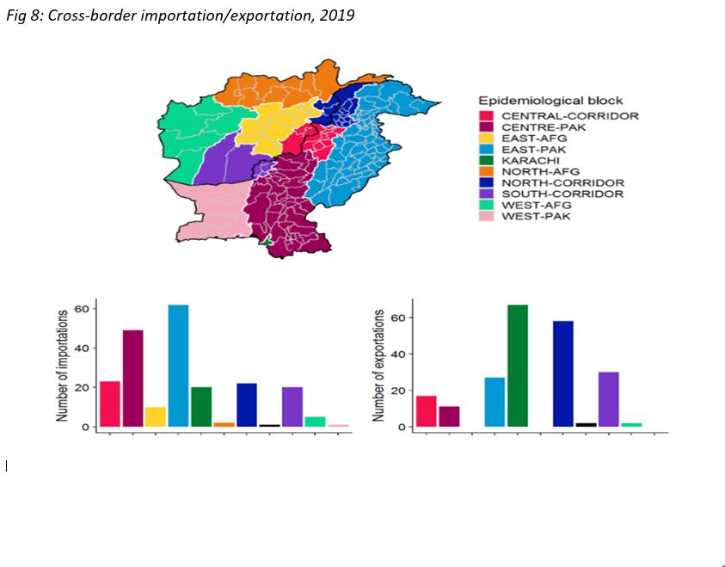
Access to and successful engagement with HRMP communities on both sides of the border remains suboptimal – constrained by security concerns, partial bans and prohibitions on programme activities (mainly Afghan side) – but also, perhaps, as a result of field-based weakness in locally-appropriate negotiators/teams/influencers unable or unwilling to seek out and engage with households who may have multiple reasons to want to avoid anything that feels like formal contact with government.

Key Questions:

Related to the knowledge shared above and from your relevant communication experience the group should keep the following questions in mind while reviewing documents and discussing the issues:

- What is your critical assessment of the programme strategy and its communication activities – does the approach and activities fit the problem?
- What are three practical communication action steps you would suggest that the polio programmes in Pakistan and Afghanistan consider to further strengthen their work focused on closing down cross-border viral movement?

Although this dynamic may be changing with the Pakistani construction of a border fence.

